
DEVELOPER INSTRUCTIONS
Job to be completed within 7 days.
1. Install the Wordpress Theme ………………………………...[provide name of theme and a link to it]
2. Customise the Theme as shown in the MOCKUP attached. [also give them the Homepage mockup you created]
3. Create the 5 PAGES (I will fill in the content later) to link to from HOME PAGE Navigation Bar [and also link from any images/content on the Homepage if you choose to do this]
Example:
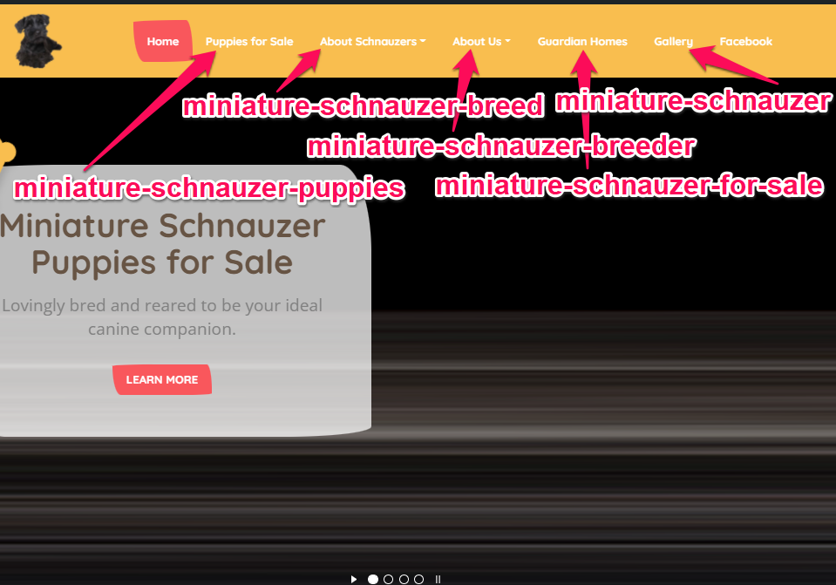
4. Provide me with the Wordpress admin login URL, username and password.
5. Create the PRIVACY POLICY page (text provided) for the website and create a link to it from the footer of the website
6. Load Rank Math plugin and use it to create a Sitemap for the website
7. Create a Google Console account for me.
8. Submit the website to Google Console and verify
9. Submit the Sitemap to Google Console
10. Load Contact 7 plugin and create a Contact Us form for the website.
Link to it from:
- The “Contact Us” Navigation Bar tab
- The website Footer at the bottom
Integrate it with my chosen webmail email address …………..[info@yourwebsite.com]
10. Go to Settings and setup Permalinks as https://www.yourwebsite.com/samplepost
11. Set up SOCIAL SHARING buttons to display on the website header for all pages using SOCIAL ICONS widget

Copyright Dr Meg Howe Jan 13, 2022 elitebreederformula.com

